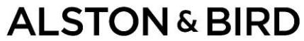
90 Park Avenue

New York, New York 10016

212­210­9400

George Silfen Direct Dial: 212­905­9106 Email: George.Silfen@alston.com

July 2, 2026

VIA EDGAR

Securities and Exchange

Commission 100 F Street, NE

Washington, DC 20549

Re: PhenixFIN Corporation (the Company") (File No. 814-00818)

Ladies and Gentlemen:

On behalf of the Company, we attach for filing, pursuant to Rule 17g-1 under the

Investment Company Act of 1940, as amended (the "1940 Act"), the following:

- A copy of the executed fidelity bond for the Company (Exhibit A); and

- A certificate covering resolutions of a majority of the independent directors approving the form and amount of the fidelity bond (Exhibit B).

Premiums for the fidelity bond have been paid for the period ending June 23, 2027.

If you have any questions regarding this filing, please call me at (212) 905-9106.

Very truly yours,

/s/ George M. Silfen

LEGAL/51530624v2



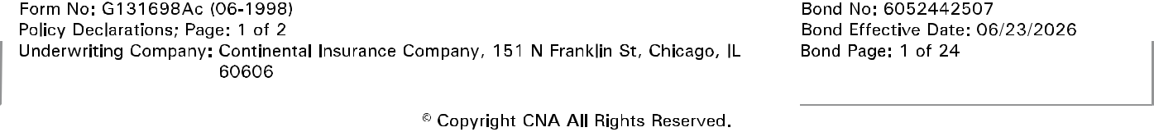
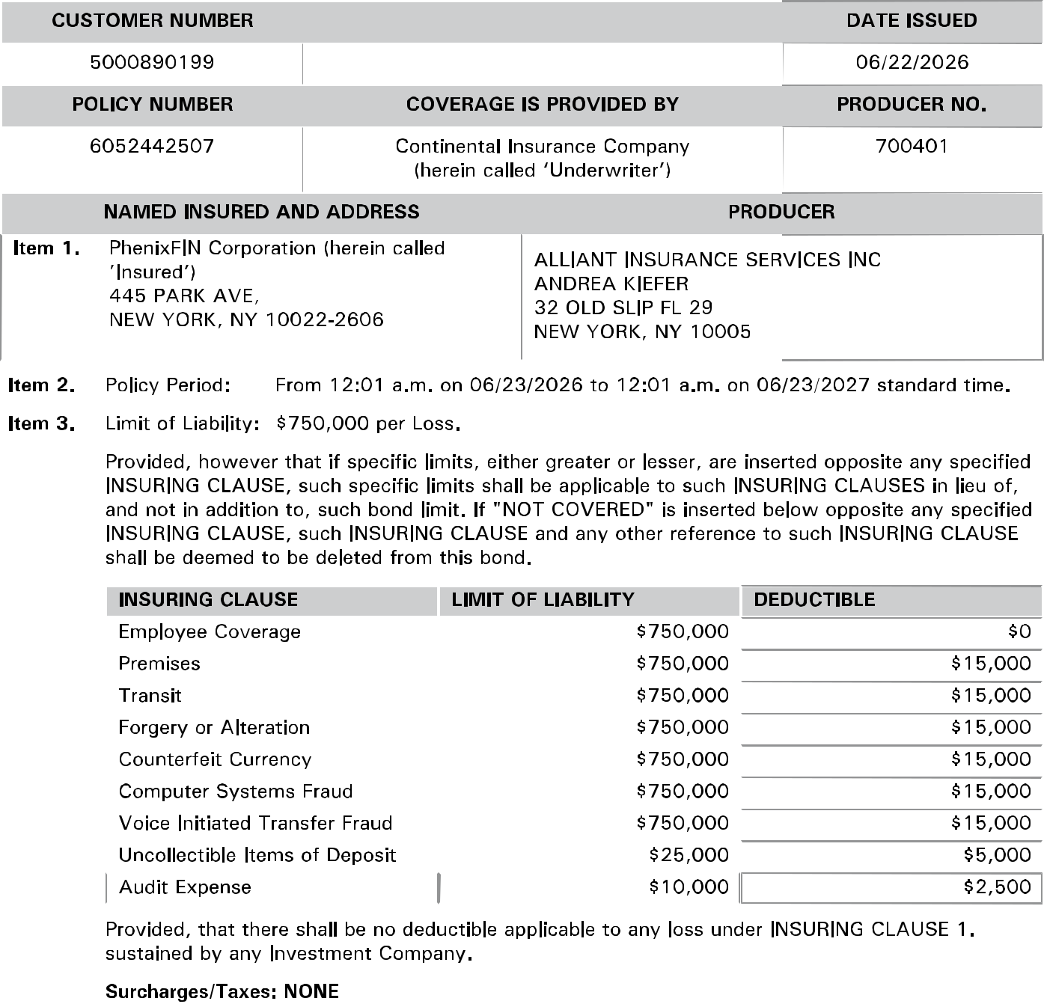

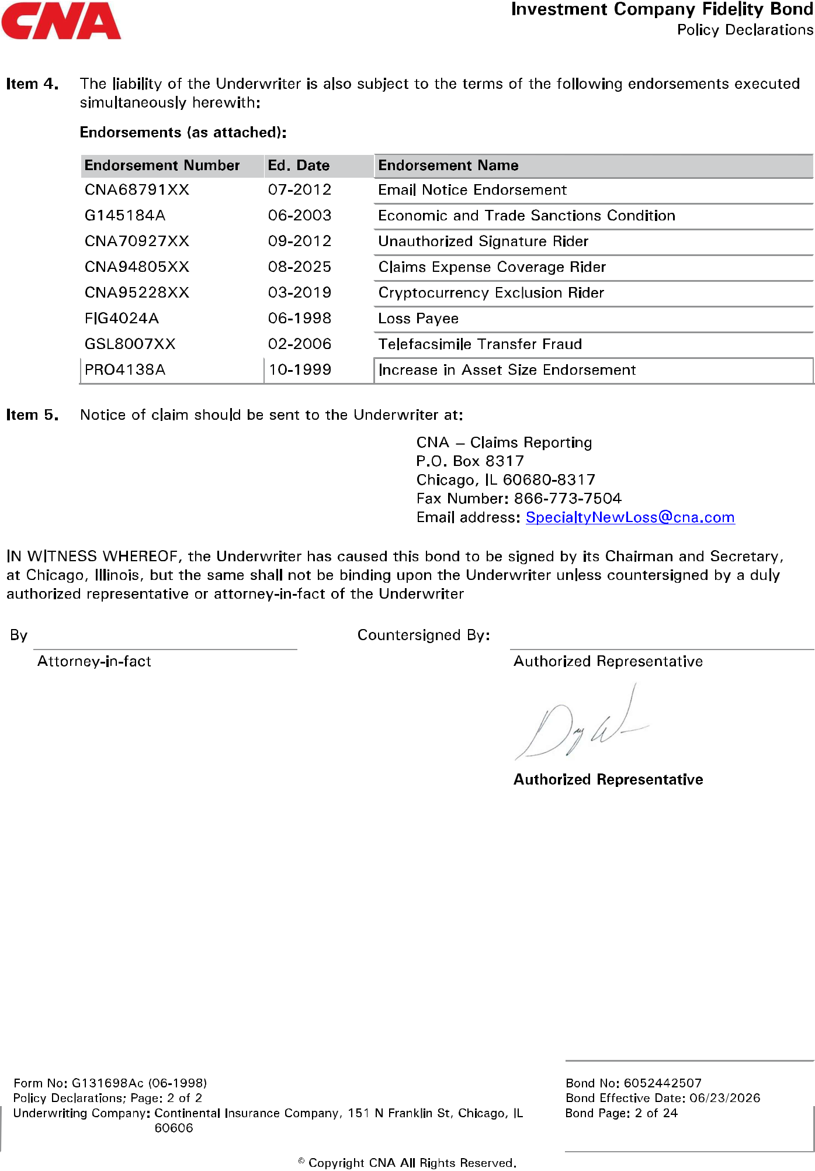


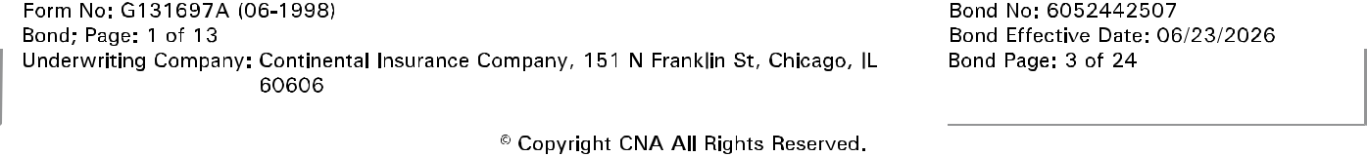
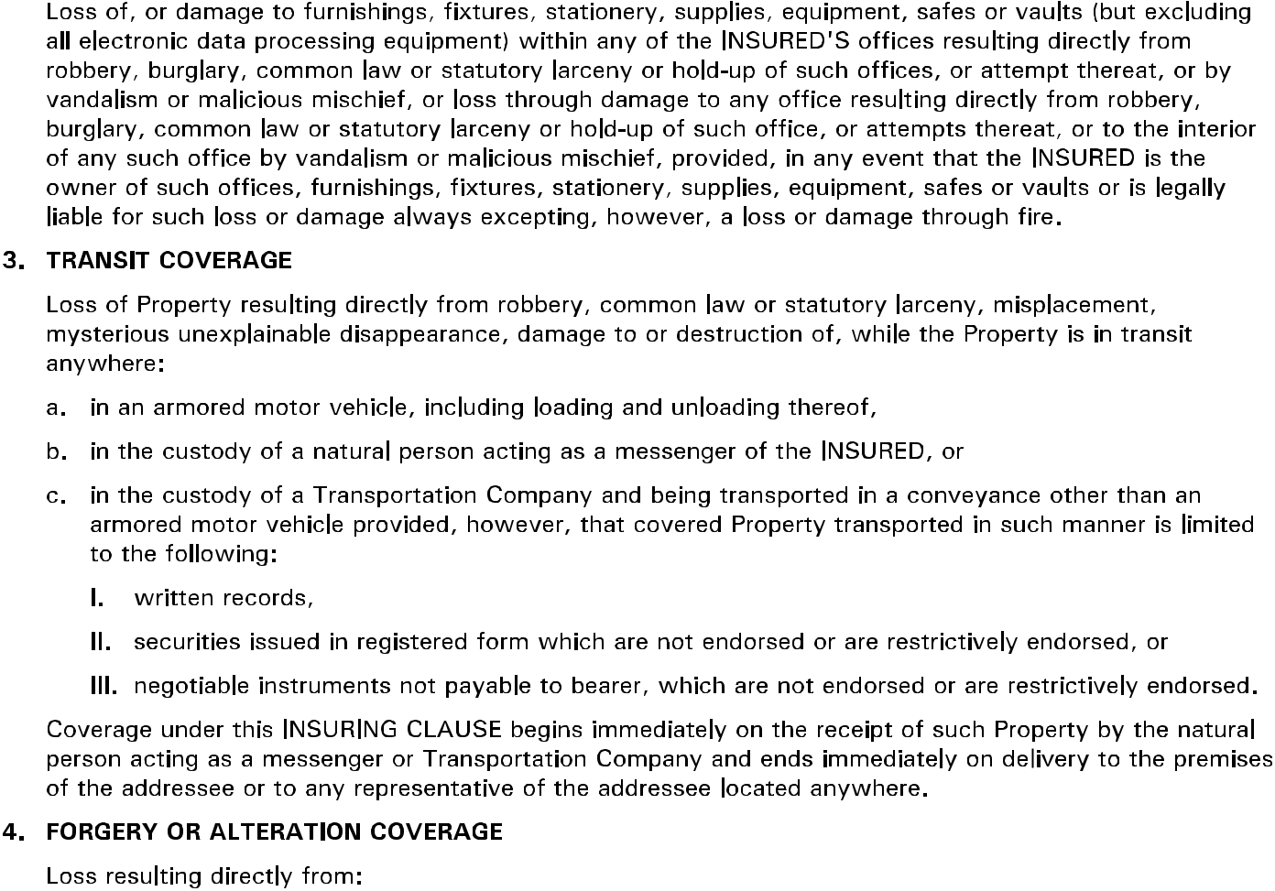

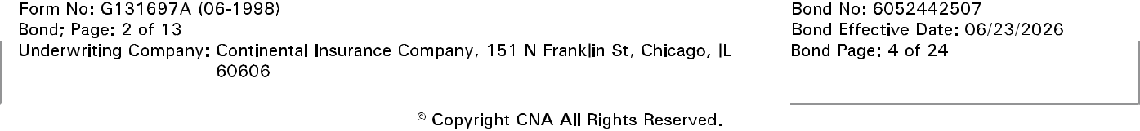
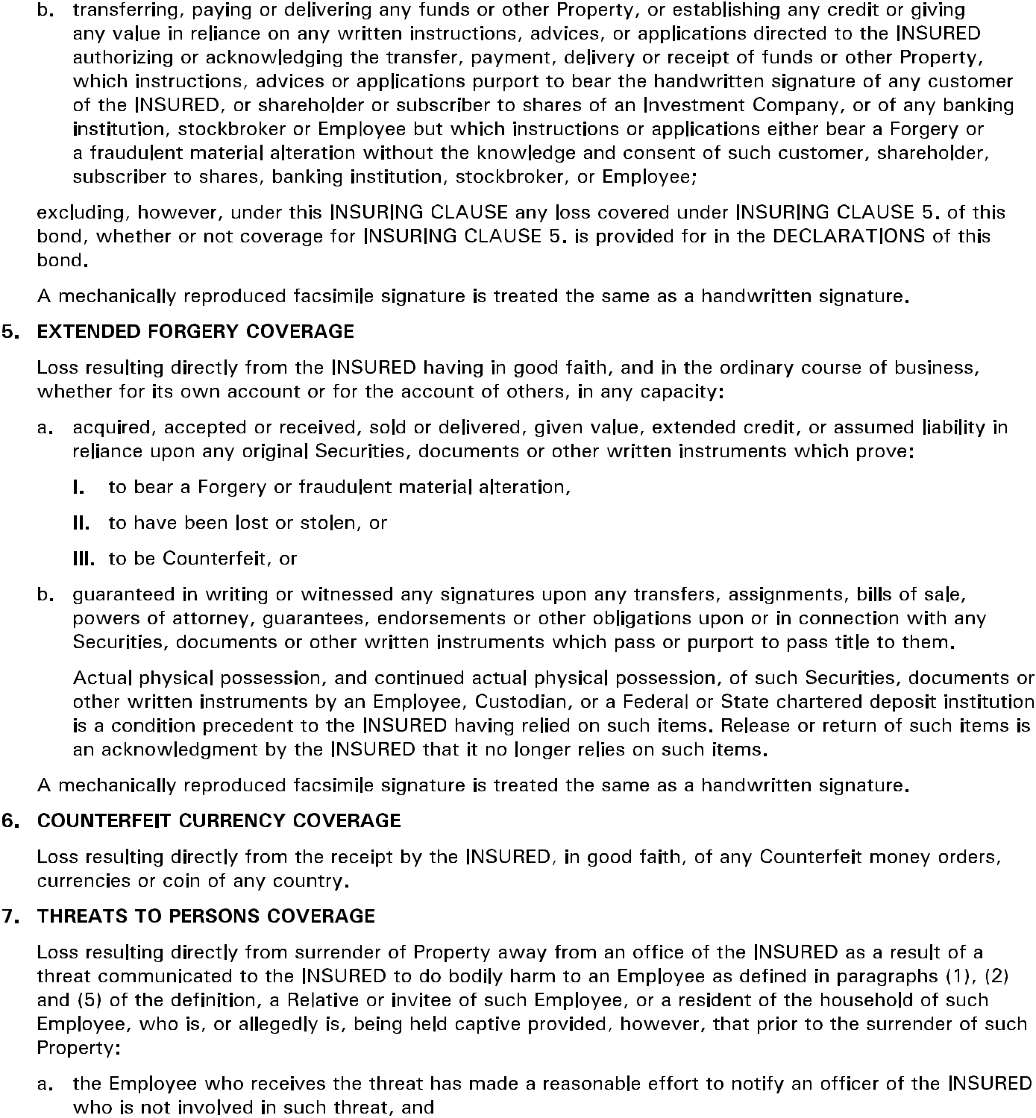

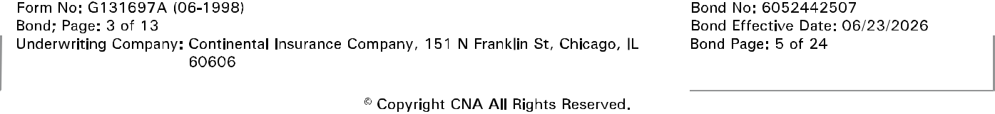
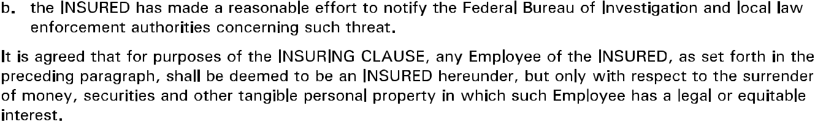
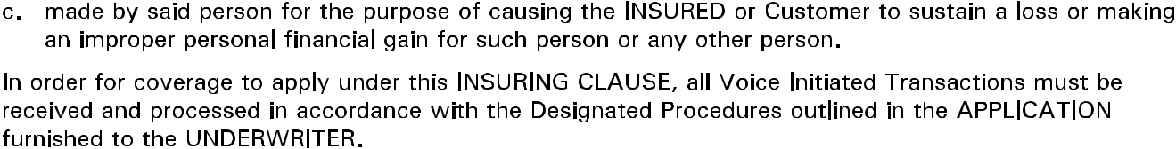
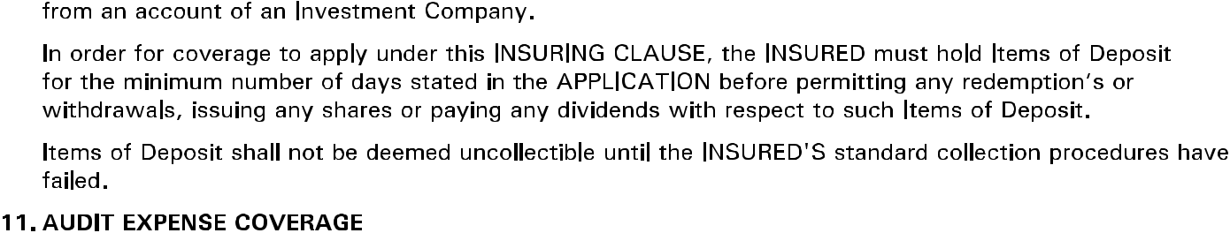

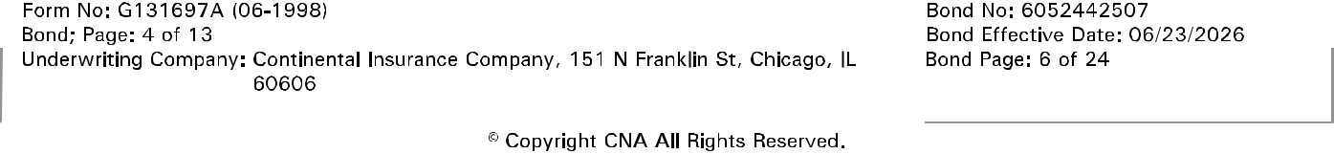
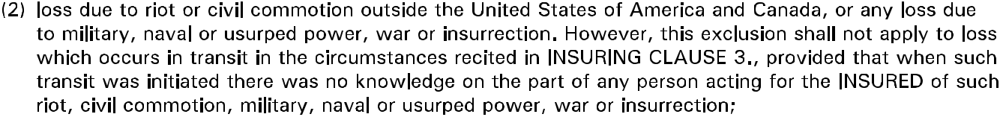

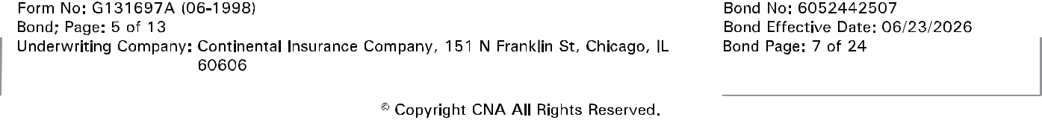
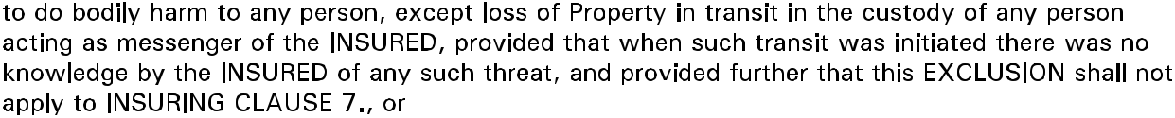
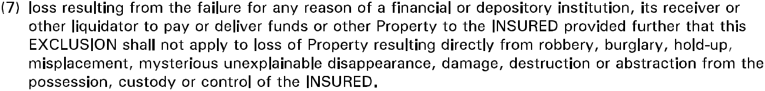

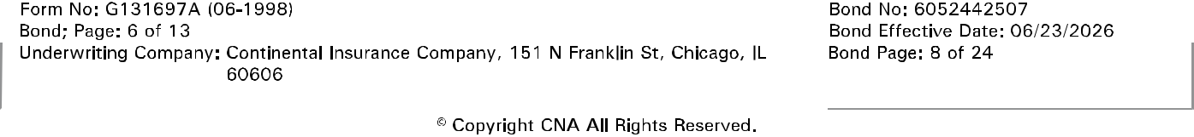
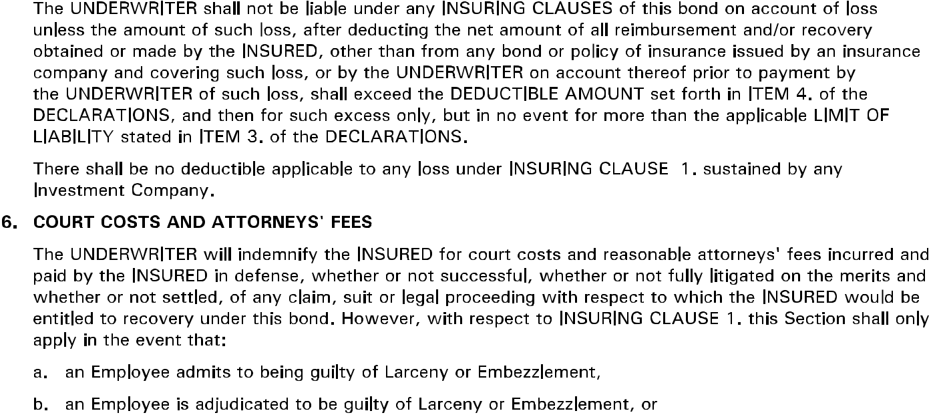

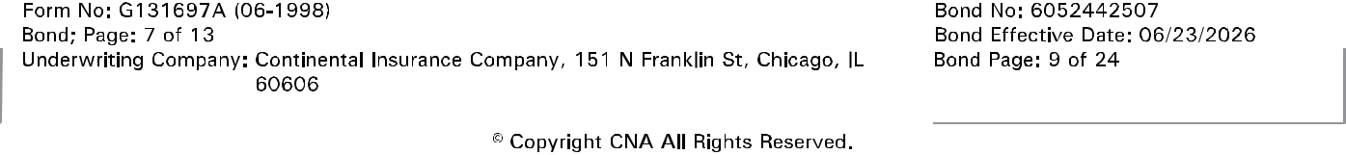
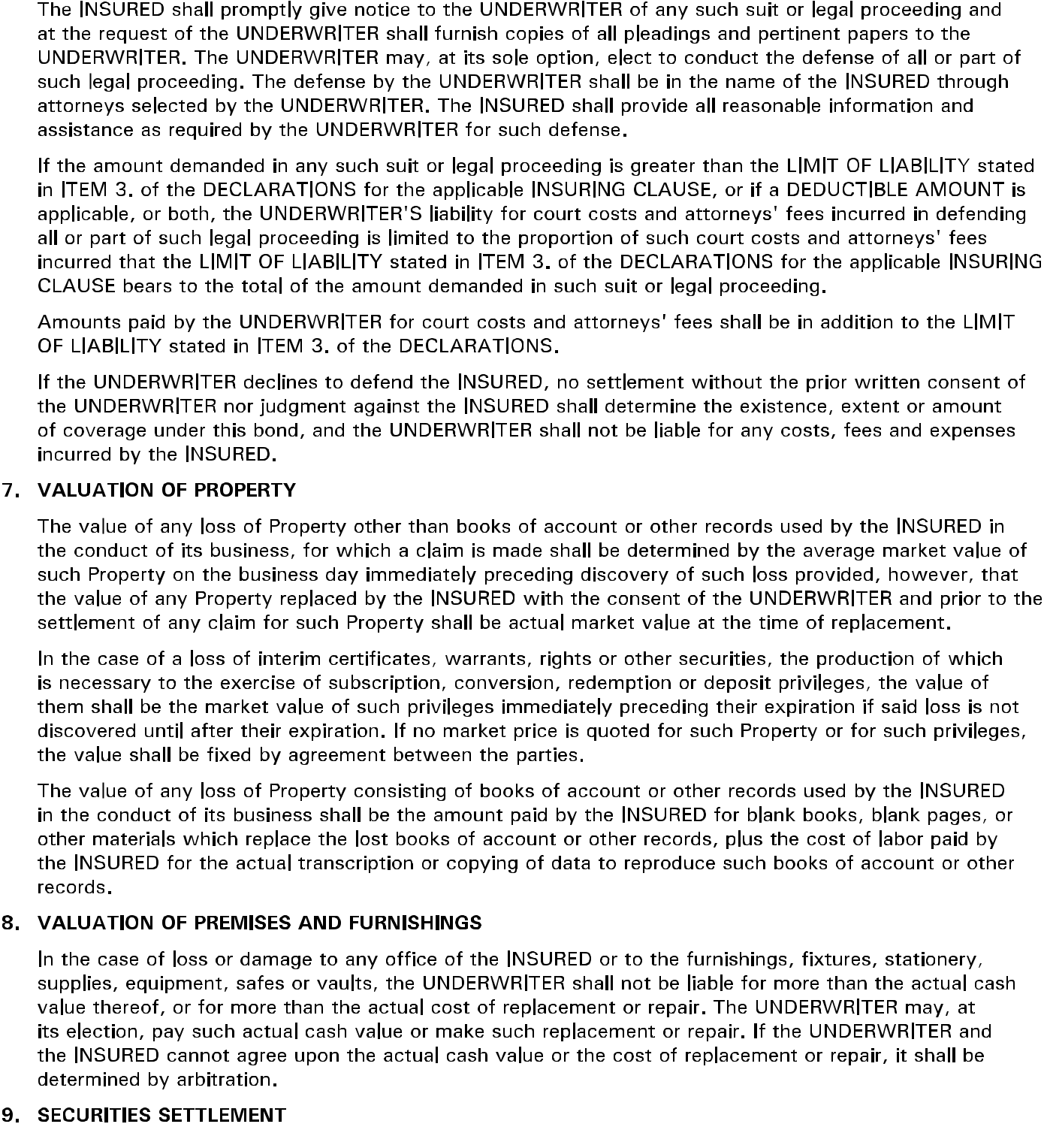

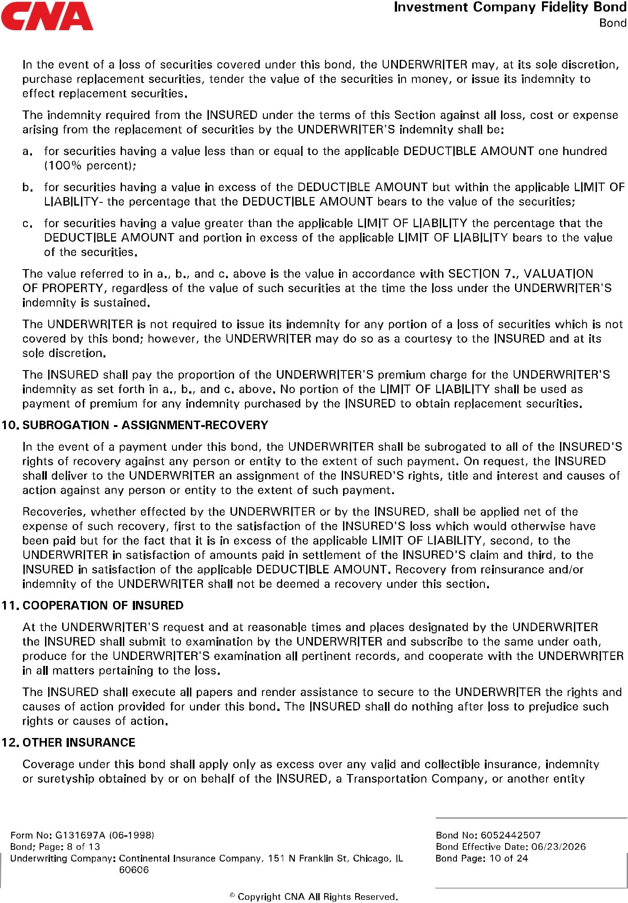

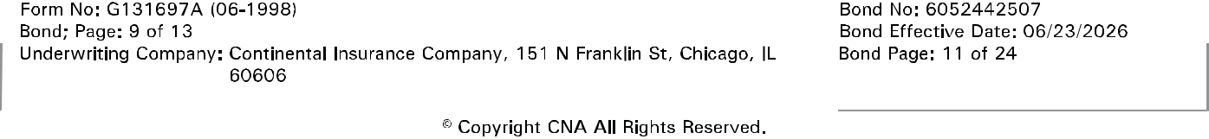
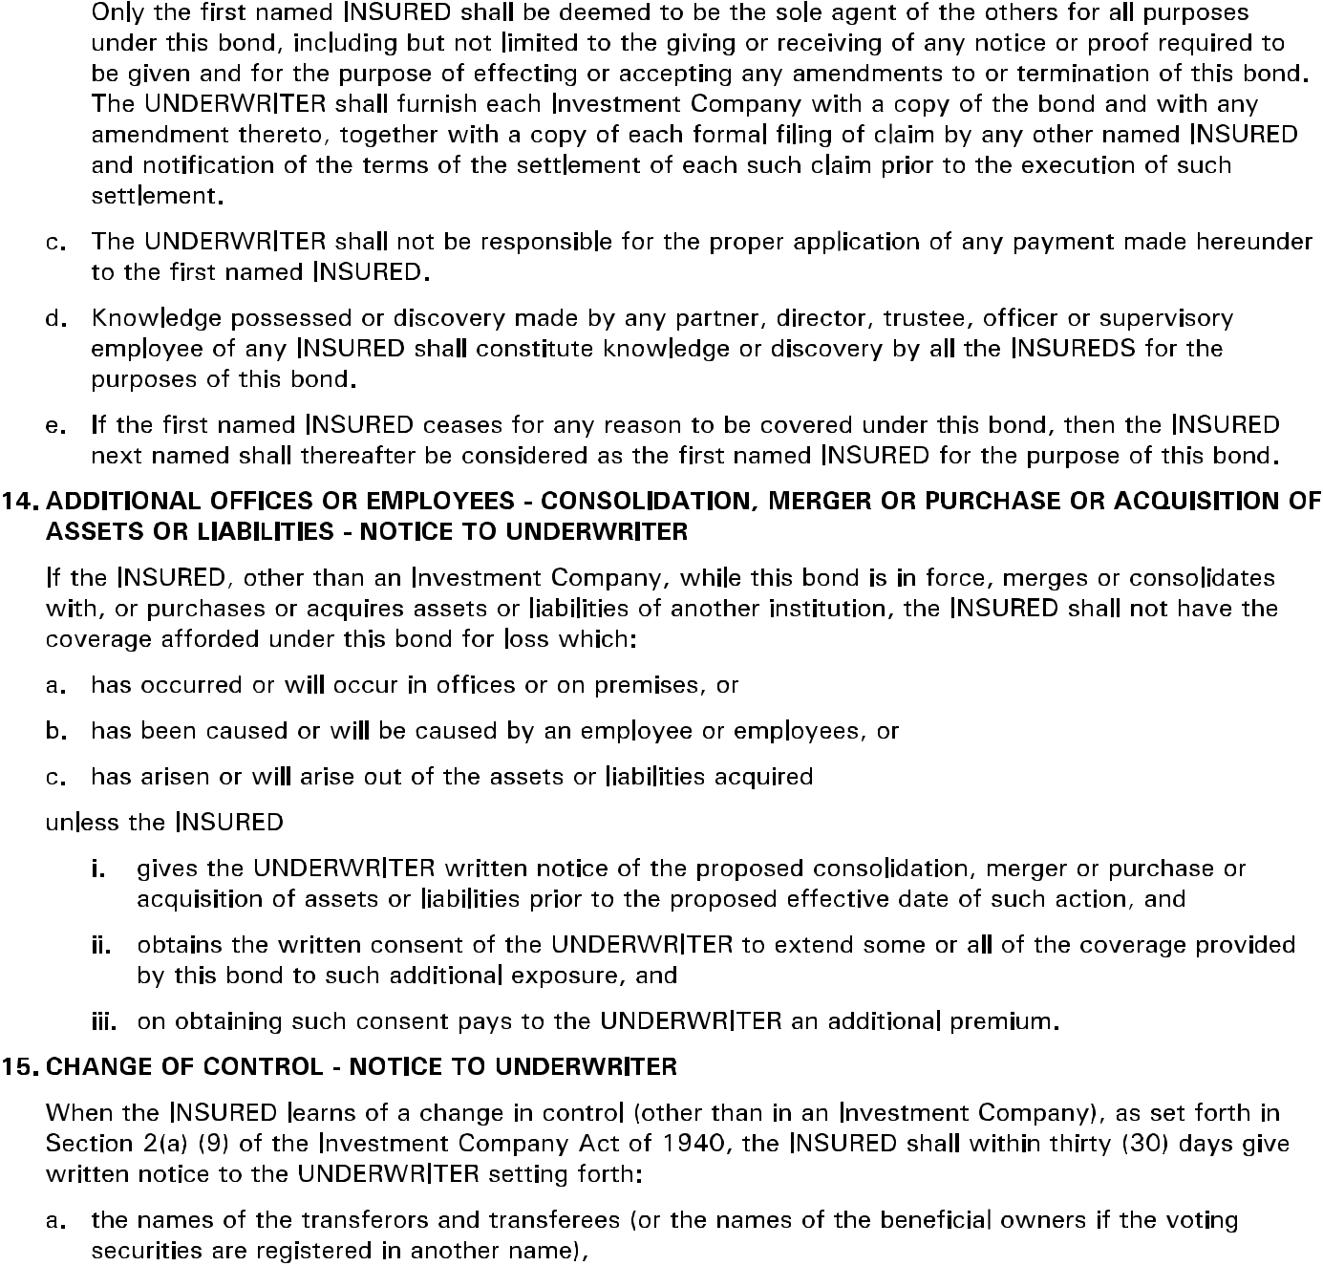

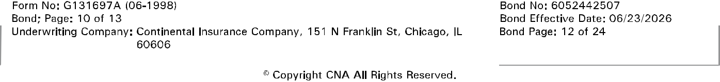
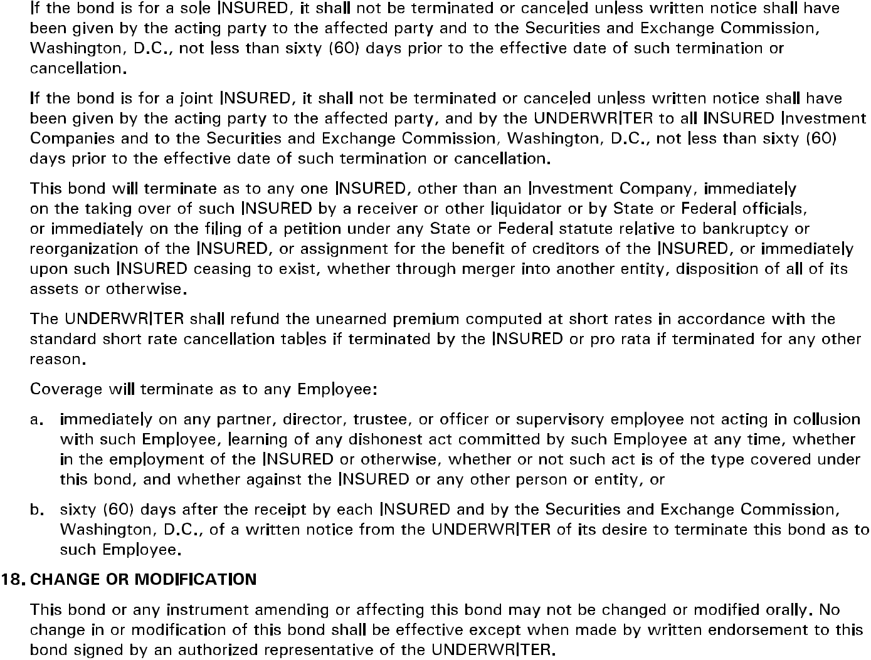

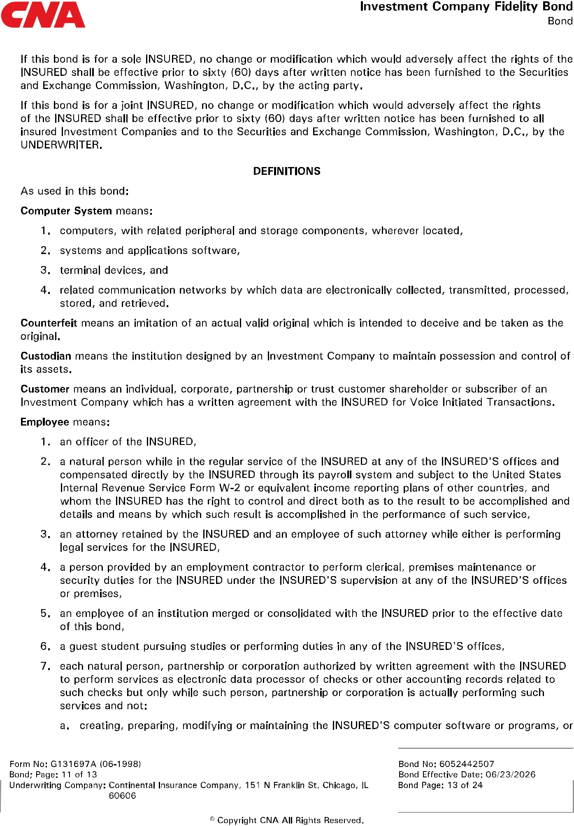

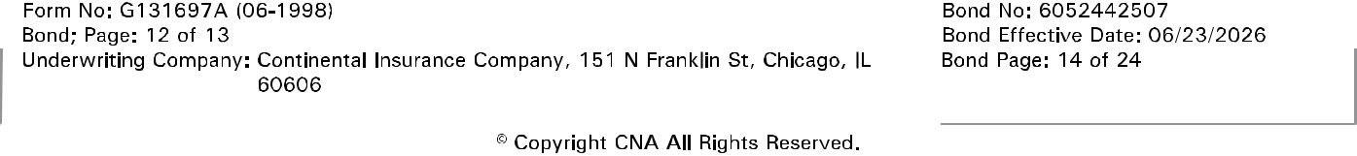
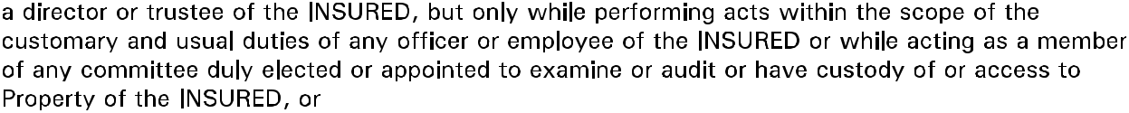
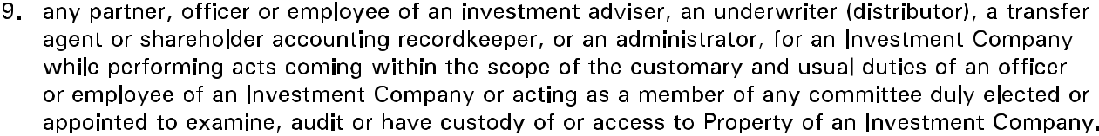
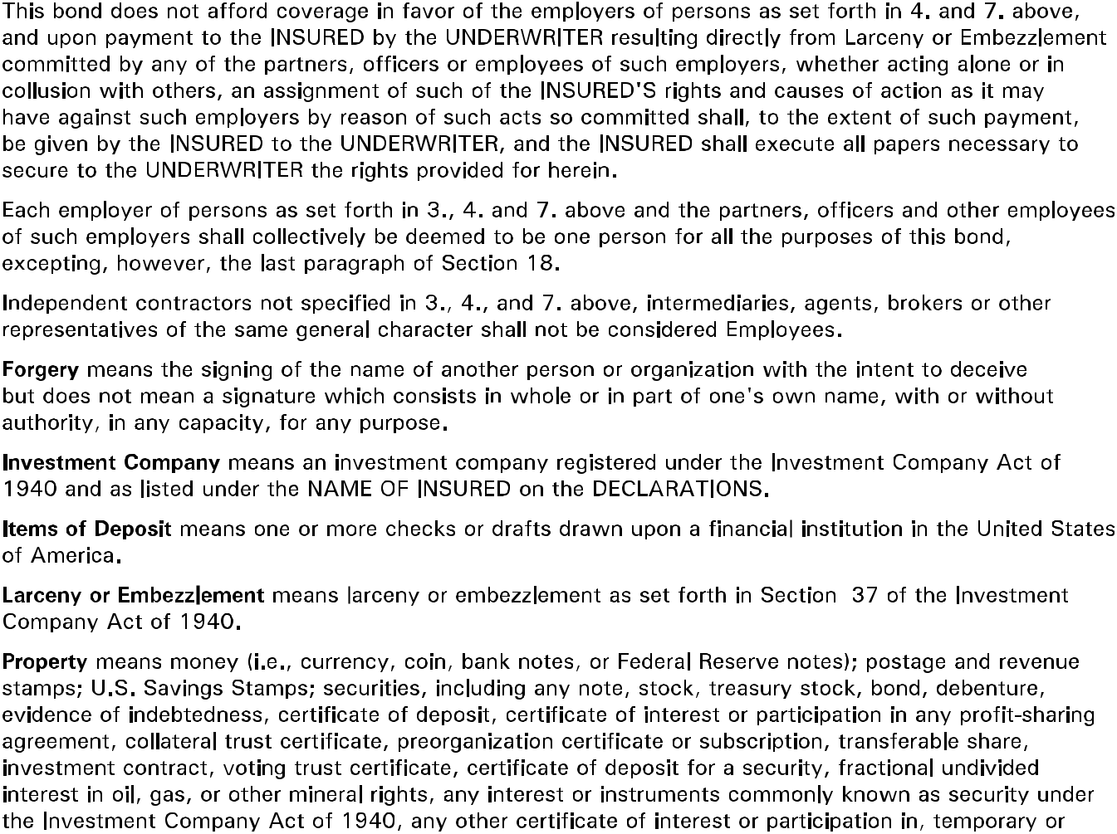

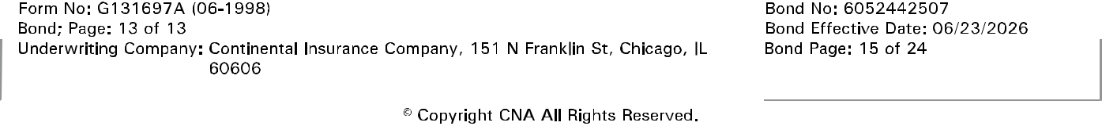
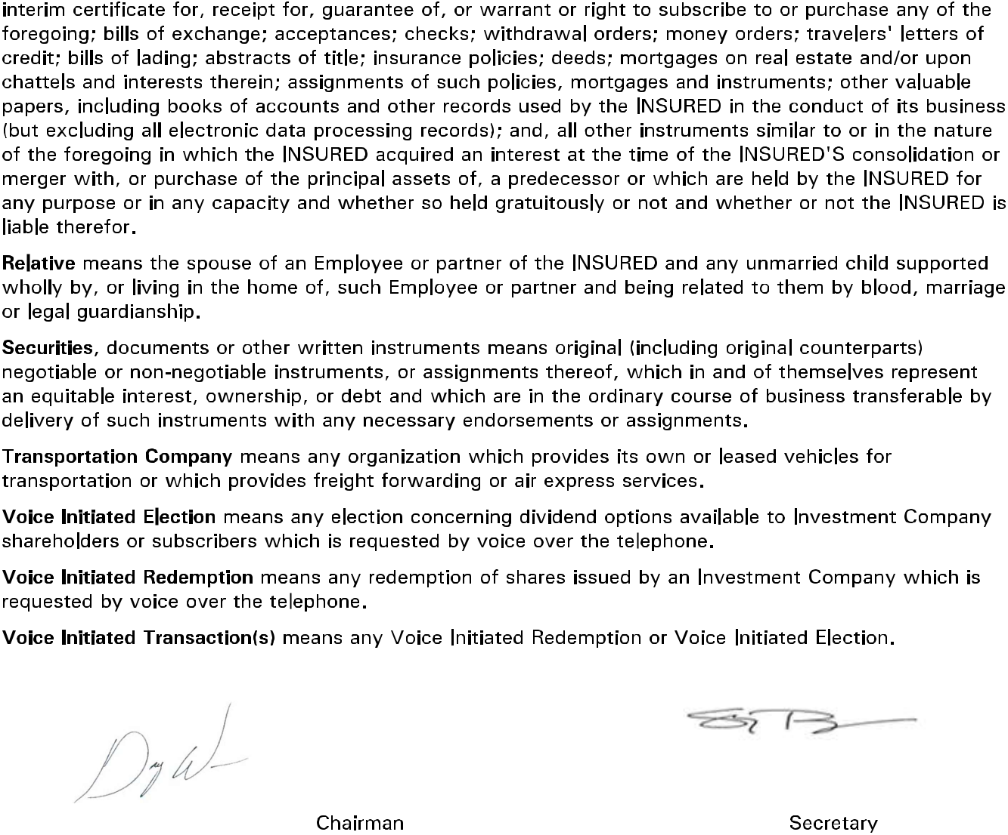

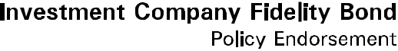
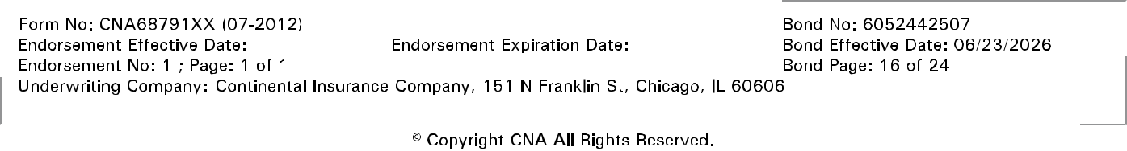
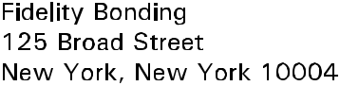

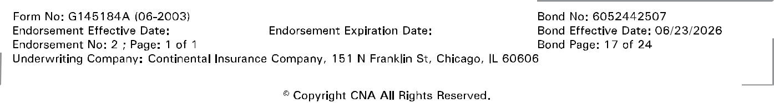



P
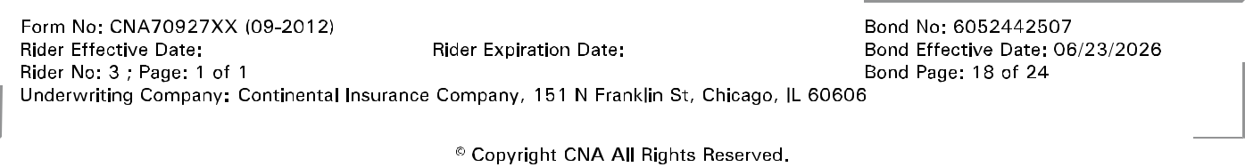
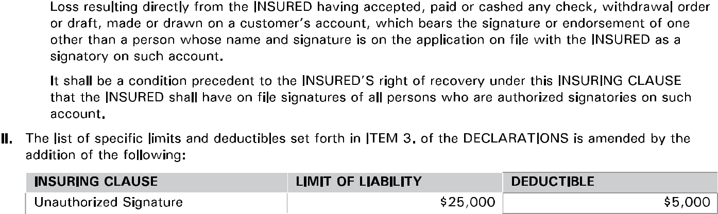

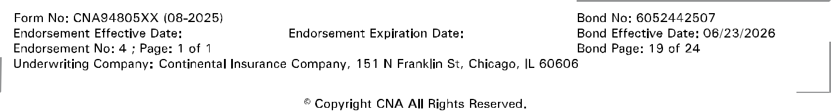

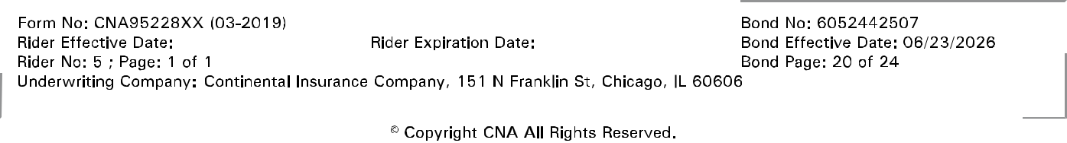
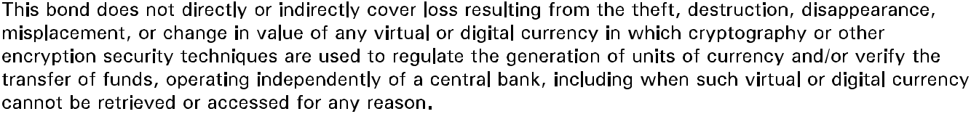

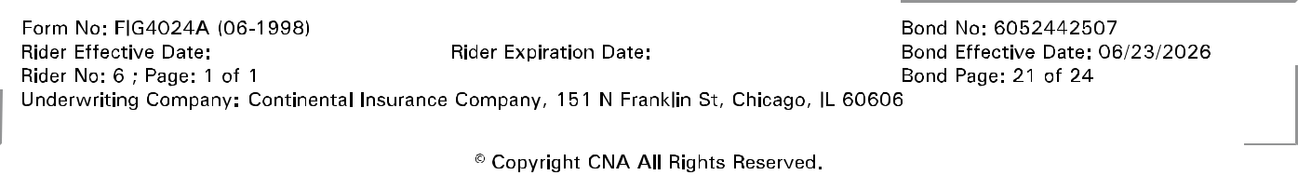

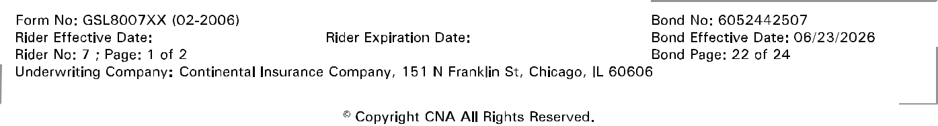
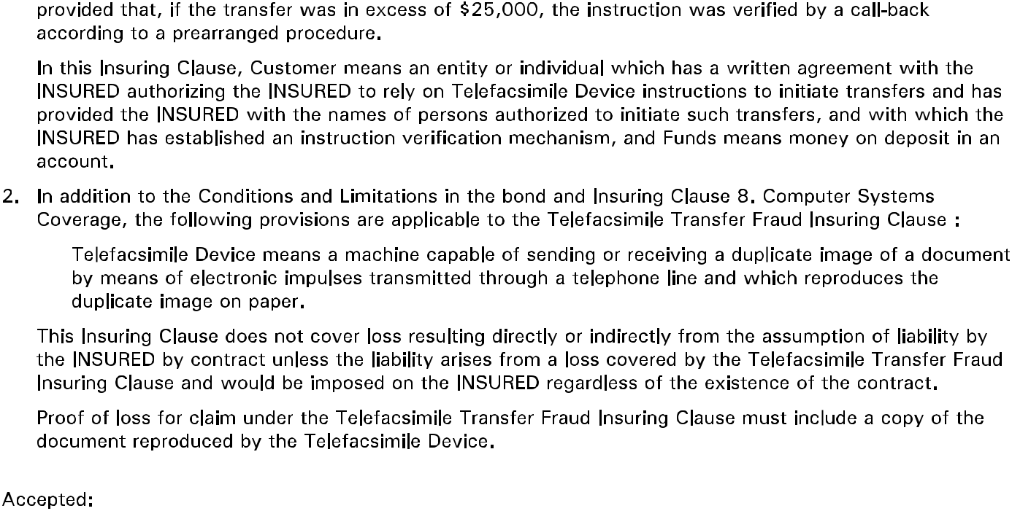

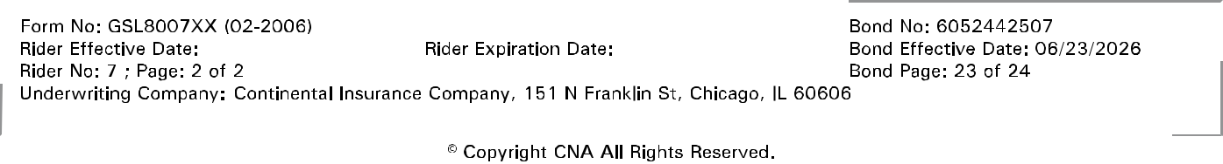

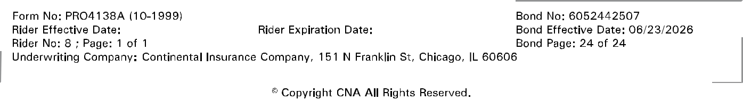
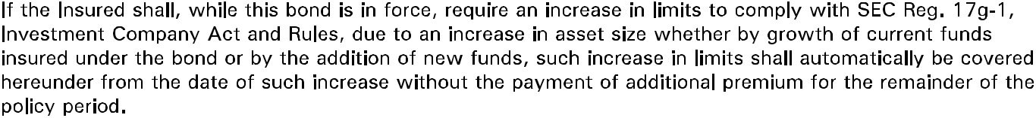

Exhibit B

I, Ellida McMillan, Chief Financial Officer of PhenixFIN Corporation (the "Company"), hereby certify that the following form of resolutions have been adopted by the Board of Directors of the Company (the "Board") at a meeting duly called and held on June 4, 2026 at which a quorum was present and acting throughout:

IN WITNESS WHEREOF, the undersigned has hereunto set her hand this 2nd day of July, 2026.

/s/ Ellida McMillan

Ellida McMillan
Chief Financial Officer

LEGAL/51530624v2

